

SOKONI WATCH
Automated Stock Monitoring System
for Local Hawkers in Nairobi, Kenya

SYSTEM DOCUMENTATION

SUBMITTED BY,
ANITA WANJIRU NJOKI
ADM NO: DIT-01-0112/2025

A SYSTEM DOCUMENTATION SUBMITTED IN PARTIAL FULFILMENT FOR THE AWARD
OF DIPLOMA IN INFORMATION COMMUNICATION TECHNOLOGY BY ZETECH UNIVERSITY

APRIL 2026

DECLARATION

I, Anita Wanjiru Njoki, hereby declare that this System Documentation is my own original work and has not been presented for examination or any other purpose to any other institution. All sources of information have been duly acknowledged.

Signature: ________________________ Date: ___________________

This System Documentation has been submitted for examination with my approval as University Supervisor.

Supervisor's Signature: ________________________ Date: ___________________

DEDICATION

This work is dedicated first and foremost to the Almighty God, whose grace has sustained me throughout this journey. To my mother, Hannah Wanjiku, who woke up every morning at 5:00 AM to sell sukuma wiki at Gikomba Market so that I could attend school — this system was built with you in mind.

To every mama mboga, uncle wa mahindi, and dada wa matunda who hustles in the streets and markets of Nairobi — from Gikomba to Toi Market, from Kawangware to Ongata Rongai — your sweat and determination inspired every line of code in Sokoni Watch.

To my classmates at Zetech University who tested, broke, and helped rebuild this system — asante sana.

ABSTRACT

Sokoni Watch is a web-based automated stock monitoring system designed specifically for local hawkers operating across various markets in Nairobi, Kenya, including Gikomba Market, Toi Market, Wakulima Market, Eastleigh Market, and City Market, among others. The system addresses a critical and persistent challenge faced by informal traders in Kenya's bustling informal economy: the inability to monitor and manage stock levels in real time, which often results in lost sales, over-purchasing, and financial losses.

The system was developed using Python and the Flask web framework for the backend, a JSON-based data store for persistent stock data, and a modern HTML, CSS, and JavaScript frontend. It supports two distinct user roles: the Admin (referred to as Bwana Sokoni), who manages the central warehouse and oversees all hawkers; and Hawker users such as Mama Njeri, Baba Kamau, and Auntie Wanjiku, who interact with the system to update their stock levels and receive low-stock alerts.

Key features include a real-time admin dashboard with aggregated statistics, automated stock alert generation with two severity levels (Warning and Critical), a stock distribution module through which the admin can push products from the central warehouse to individual hawkers, a Market Pulse view that shows which categories and products are selling fastest across the network, and a hawker-facing dashboard that shows each vendor their personalized stock levels and hot-selling items.

The system was tested using simulated sales data across eight hawker accounts and over seventy product lines across seven categories including Mboga (vegetables), Matunda (fruits), Nafaka (grains), Samaki (fish), Nyama (meat), Vinywaji (beverages), and Viungo (spices). Sokoni Watch has demonstrated reliable performance and presents a viable digital solution for formalizing and modernizing stock management among Nairobi's informal hawker community.

DEFINITION OF KEY TERMS

Hawker: A hawker refers to an informal trader or street vendor who sells goods — typically food items such as vegetables, fruits, grains, and fish — in public markets or open-air spaces. In Kenya, hawkers are a vital part of the informal economy and form the backbone of food distribution in urban areas like Nairobi.

Stock Monitoring: The process of tracking the quantity of goods available for sale at any given time. Automated stock monitoring uses software and data processing to continuously observe and record inventory levels without manual counting.

Alert: A system-generated notification that is triggered when a product's stock level falls below a defined minimum threshold. In Sokoni Watch, alerts are categorized as either 'Warning' (stock below minimum) or 'Critical' (stock below 50% of minimum threshold).

Admin Warehouse: The central storage facility managed by the Admin (Bwana Sokoni) that serves as the primary source of stock for all registered hawkers. Products are distributed from this warehouse to individual hawkers through the system.

Market Pulse: A real-time analytical view in Sokoni Watch that aggregates sales data across all hawkers to show which product categories and individual items are selling fastest, helping both admin and hawkers make informed restocking decisions.

M-Pesa Till: A registered M-Pesa mobile money till number assigned to a hawker for receiving digital payments. Sokoni Watch stores each hawker's M-Pesa till number as part of their profile to support future payment integrations.

REST API: Representational State Transfer Application Programming Interface — a set of URL-based routes (endpoints) through which the frontend and backend of Sokoni Watch communicate and exchange data in JSON format.

ABBREVIATIONS AND ACRONYMS

Abbreviation | Full Meaning
API | Application Programming Interface
CSS | Cascading Style Sheets
DFD | Data Flow Diagram
HTML | HyperText Markup Language
HTTP | HyperText Transfer Protocol
ICT | Information and Communication Technology
IDE | Integrated Development Environment
JSON | JavaScript Object Notation
JS | JavaScript
KES | Kenyan Shilling
M-Pesa | Mobile Pesa (Mobile Money)
REST | Representational State Transfer
SMS | Short Message Service
UI | User Interface
URL | Uniform Resource Locator

LIST OF FIGURES

Figure 2.2.1 — Login Page UI Design (Hand-sketched wireframe)
Figure 2.2.2 — Admin Dashboard UI Design
Figure 2.2.3 — Warehouse Management UI Design
Figure 2.2.4 — Stock Distribution Form Design
Figure 2.2.5 — Hawker Stock View Design
Figure 2.3.1 — Stock Alert Generation Flowchart
Figure 2.3.2 — Data Flow Diagram (Level 1)
Figure 2.3.3 — Use Case Diagram
Figure 2.3.4 — System Architecture Diagram
Figure 3.2.1 — Login Page Screenshot
Figure 3.2.2 — Admin Dashboard Screenshot
Figure 3.2.3 — Warehouse Management Screenshot
Figure 3.2.4 — Stock Distribution Screenshot
Figure 3.2.5 — Hawker Stock View Screenshot
Figure 3.2.6 — Market Pulse Screenshot
Figure 3.2.7 — Alerts Management Screenshot

LIST OF TABLES

Table 1.4.1 — Functional Requirements Table
Table 1.5.1 — Project Resources
Table 1.6.1 — Project Schedule Breakdown
Table 3.4.1 — System Testing Results

TABLE OF CONTENTS

CHAPTER ONE: PROJECT PLANNING AND ANALYSIS

1.1 Statement of Problem
The informal hawker economy in Nairobi, Kenya, is a cornerstone of the city's food supply chain, employing hundreds of thousands of vendors across markets such as Gikomba, Toi Market, Wakulima, Kangemi, Korogocho, Githurai 44, and Ongata Rongai. Despite their economic significance, the vast majority of these traders — including vegetable sellers like Mama Njeri, fruit vendors like Baba Kamau, and grain traders like Auntie Wanjiku — rely entirely on manual, intuition-based methods of managing their inventory. Stock is tracked mentally, in handwritten notebooks, or not at all.

This absence of structured stock management leads to a cascading series of operational and financial challenges. Hawkers frequently run out of fast-selling items such as Sukuma Wiki, Tomatoes, and Unga wa Mahindi during peak demand periods, losing potential customers and revenue. Conversely, they also over-purchase perishable goods that then go to waste before they can be sold. Without visibility into market-wide demand trends, a hawker at Eastleigh Market has no way of knowing that Embe (mangoes) are selling exceptionally fast across the network that particular morning.

At the wholesale level, the central stock supplier — Bwana Sokoni (the Admin) — faces an equally disorganized challenge: he cannot efficiently track which of his hawkers are running low on which products, meaning restocking decisions are reactive rather than proactive. Products may be distributed unequally, with some hawkers receiving too much stock and others too little. This inefficiency results in economic losses throughout the supply chain — from the warehouse all the way to the customer buying their evening sukuma wiki.

Sokoni Watch was developed to directly address these interconnected problems by providing an automated, role-based digital platform that gives both the admin and individual hawkers real-time visibility into stock levels, automated alerts when thresholds are crossed, and the tools to take immediate corrective action.

1.2 Study Justification
The development of Sokoni Watch is justified on multiple grounds — economic, technological, and social. Kenya has one of the most dynamic informal economies on the African continent, with the informal sector accounting for approximately 34% of GDP according to the Kenya National Bureau of Statistics. Within this sector, hawkers and informal food traders are among the most active participants, collectively handling millions of shillings in daily transactions across Nairobi alone.

Despite this economic weight, digital tools designed specifically for this demographic are almost entirely absent from the market. Existing enterprise inventory management solutions such as QuickBooks or Odoo are far too expensive, complex, and culturally irrelevant for a mama mboga who sells Sukuma Wiki at Gikomba Market. Sokoni Watch fills this specific gap by providing a lightweight, bilingual (Swahili and English), mobile-friendly system that fits the operational reality of Nairobi's hawkers.

Furthermore, Kenya's high mobile phone penetration rate — estimated at over 90% for basic phones and growing rapidly for smartphones — makes a web-based system particularly viable. A hawker with a basic Android smartphone and a Safaricom data bundle can access Sokoni Watch from anywhere in Nairobi. The system's design deliberately avoids complex navigation and uses familiar Swahili terminology such as 'Tafuta Bidhaa' (search for products) and 'Ongeza Mwuza' (add a hawker) to ensure accessibility.

The development of this system also contributes to the broader national agenda of digitizing Kenya's economy as outlined in Vision 2030 and the Bottom-Up Economic Transformation Agenda (BETA), which specifically targets the empowerment of informal traders. By automating stock monitoring and enabling data-driven decision-making for hawkers, Sokoni Watch helps reduce waste, improve profitability, and formalize a segment of the economy that has historically operated entirely off the grid.

1.3 System Objectives

1.3.1 General Objective
To develop an automated web-based stock monitoring and distribution system for local hawkers operating in Nairobi's informal markets, enabling real-time tracking of inventory levels, automated alert generation, and centralized stock distribution management.

1.3.2 Specific Objectives
- To implement a dual-role authentication system allowing Admin (Bwana Sokoni) and Hawker users such as Mama Njeri and Baba Kamau to securely log in and access role-appropriate dashboards and features.
- To implement automated stock alert generation that detects when any hawker's product stock falls below a defined minimum threshold, classifying alerts as either Warning or Critical severity.
- To implement a stock distribution module enabling the Admin to transfer specific quantities of products from the central warehouse directly to registered hawkers in the system.
- To implement a Market Pulse analytics view that aggregates real-time sales data across all hawkers to identify the fastest-selling products and categories across the Nairobi hawker network.

1.4 Functional Requirements
The table below outlines the functional requirements of the Sokoni Watch system, describing what each user type can do and the features that support those activities.

User | User Activities | Features
Admin (Bwana Sokoni) | Login and access admin dashboard; manage all hawker accounts; monitor entire hawker network; manage central warehouse stock; distribute stock to individual hawkers; view all system-wide alerts; view Market Pulse analytics; simulate sales activity for testing | Admin Dashboard with live statistics; Hawker Management panel; Warehouse Management module; Stock Distribution tool; Alert Management centre; Market Pulse analytics; Sales Simulation tool
Hawker (e.g. Mama Njeri) | Login and access personal hawker dashboard; view own stock levels with visual indicators; record daily sales and update stock quantities; view personalized low-stock alerts; see what products are hot market-wide | Personal Hawker Dashboard with my stats; My Products stock view with progress bars; Record Sale and Update Stock controls; My Alerts panel; Market Pulse view (read-only)

Table 1.4.1 Functional Requirements of Sokoni Watch

1.5 Project Resources
The development of Sokoni Watch required the following categories of resources, all of which were sourced within a student project budget, making use of free and open-source tools wherever possible.

1. Software Resources
- Python 3.11 — Backend programming language used to develop all server-side logic
- Flask Framework — Lightweight Python web framework used to build the REST API and serve web pages
- Visual Studio Code (VS Code) — Primary Integrated Development Environment (IDE) used for writing all code
- Git and GitHub — Version control system used to track code changes and maintain the project repository
- Google Chrome and Mozilla Firefox — Web browsers used for testing the user interface

2. Hardware Resources
- Development Machine: HP Laptop with Intel Core i5, 8GB RAM, 256GB SSD running Windows 11
- Test Devices: Tecno Spark 10 smartphone and Samsung Galaxy A13 for mobile browser testing
- Internet Connection: Safaricom 4G mobile data for downloading libraries and testing remote accessibility

3. Human Resources
- System Developer: Anita Wanjiru Njoki — Designed, developed, tested, and documented the entire system
- Test Users: Seven classmates at Zetech University who acted as hawker personas during usability testing
- Project Supervisor: Mr. James Odhiambo — Provided academic guidance and evaluation throughout the project

Resource Category | Item | Cost/Source
Software | Python, Flask, VS Code, Git | Free/Open Source
Hardware | Personal HP Laptop | Personal (owned)
Internet | Safaricom 4G Data | KES 1,000/month
Hosting | Localhost / PythonAnywhere | Free (testing)
Documentation | Microsoft Word, Google Docs | Student License / Free

Table 1.5.1 Project Resources

1.6 Project Schedule Breakdown
The development of Sokoni Watch was organized into five major milestones spread over a twelve-week period from January to April 2026. Each phase built progressively on the previous one, from initial planning through to final presentation. The schedule below reflects the actual timeline followed during development.

Weeks | Phase 1: Planning & Analysis | Phase 2: Design & Modeling | Phase 3: Development & Testing | Phase 4: Deployment | Phase 5: Final Touches & Presentation
7–9 Jan | ✓ Done
12–16 Jan | ✓ Done
19–23 Jan |  | ✓ Done
26–30 Jan |  | ✓ Done
2–6 Feb |  |  | ✓ Done
9–13 Feb |  |  | ✓ Done
16–20 Feb |  |  | ✓ Done
23–27 Feb |  |  |  | ✓ Done
2–6 Mar |  |  |  | ✓ Done
9–13 Mar |  |  |  |  | ✓ Done
16–20 Mar |  |  |  |  | ✓ Done
23–27 Mar |  |  |  |  | ✓ Done
3rd April |  |  |  |  | ✓ Presentation

Table 1.6.1 Project Schedule Breakdown

CHAPTER TWO: DESIGN AND MODELING

2.1 Introduction to Modelling
System modelling is the process of creating abstract representations of a system to help developers, designers, and stakeholders visualize and understand how that system will function before any actual code is written. In the development of Sokoni Watch, system modelling played a critical and foundational role that shaped every subsequent phase of the project — from the structure of the Flask backend to the layout of each dashboard view.

Before a single line of Python or HTML was written, the developer invested significant time in sketching out how the system would look and behave. This involved drawing wireframes of every major screen — the login page, the admin dashboard, the warehouse management view, the stock distribution form, and the hawker-facing stock panel. It also involved drawing logical models: flowcharts that traced the journey of a stock alert from detection to resolution, data flow diagrams that showed how data moved between hawkers, the Flask server, and the JSON data store, and use case diagrams that mapped out every interaction each user type could have with the system.

The benefits of this modelling phase were immediately apparent during development. By the time coding began, the developer already knew exactly what API endpoints were needed, what data structures the JSON store would require, and how the frontend JavaScript would need to interact with the backend. Problems that might otherwise have been discovered mid-development — such as the need for a separate alert-generation function or the requirement for a Market Pulse aggregation endpoint — were identified and resolved at the design stage, saving hours of debugging and refactoring later.

This chapter presents all the design models that were created during the modelling phase, organized into two categories: User Interface Models (wireframes and UI sketches) and Logic Models (flowcharts, DFDs, use case diagrams, and architecture diagrams).

2.2 User Interface Models
The user interface models below represent the initial wireframe and sketch designs created before any HTML or CSS was written. These designs served as the visual blueprint for every screen in the Sokoni Watch system.

2.2.1 Login Page Design
The login page was designed to serve as the entry gate for both user types — Admin and Hawker. The design prioritized clarity and cultural familiarity, using bilingual labels (English and Swahili) to ensure usability for hawkers who may not be fully comfortable with English-only interfaces. The form includes two fields: a username field (labeled 'Jina la Mtumiaji') and a password field (labeled 'Neno Siri'). A prominent 'Ingia — Login' button styled in the system's gold brand color serves as the primary call-to-action. The design also incorporates the Sokoni Watch branding prominently at the top, establishing trust and identity from the very first interaction.

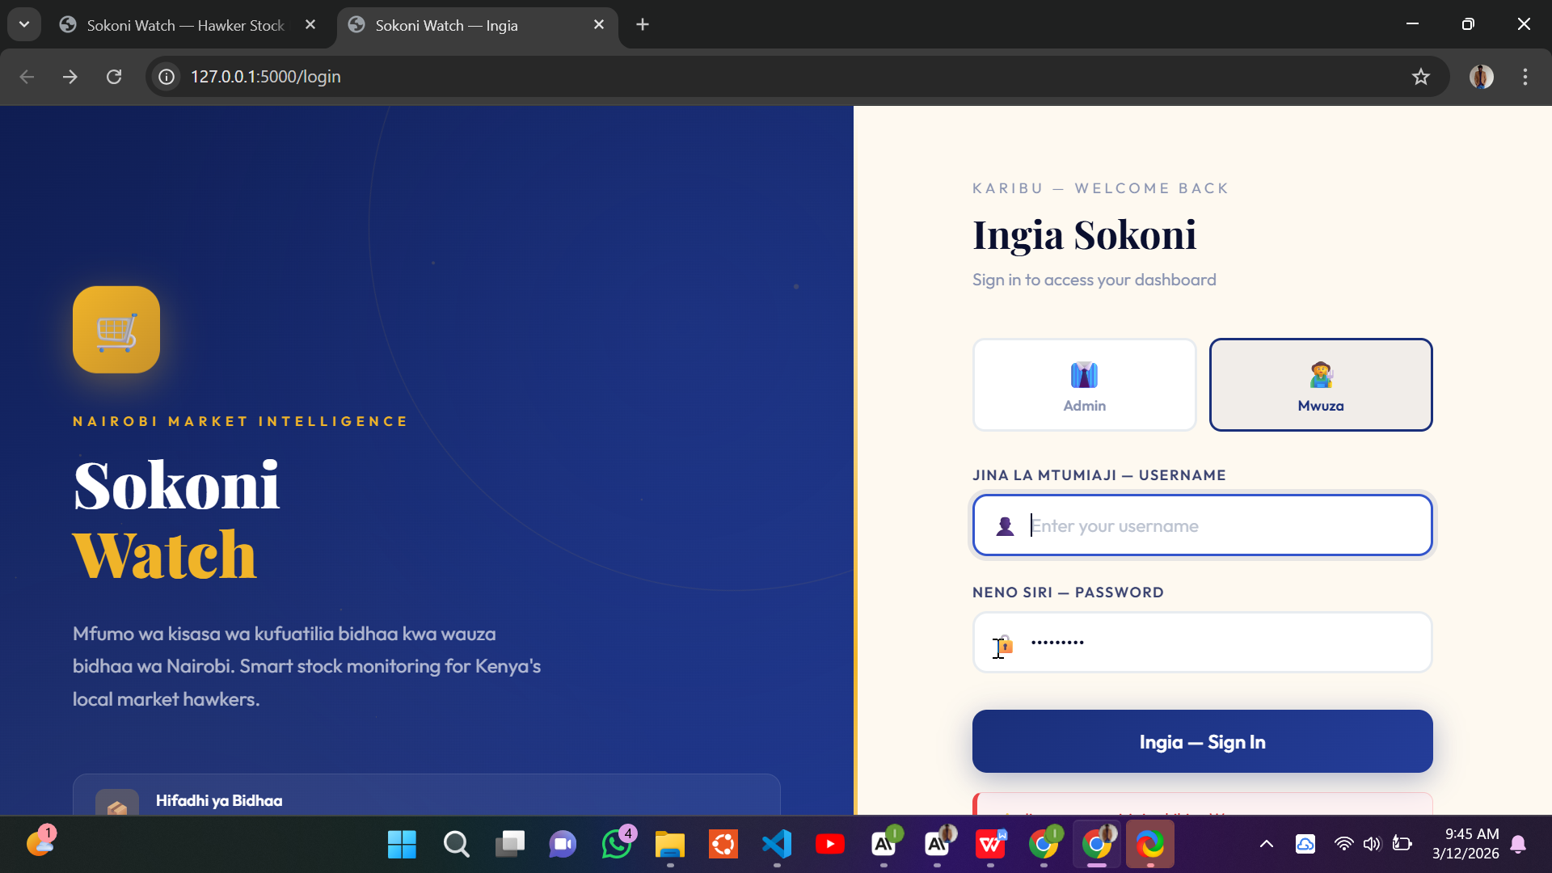
Figure 2.2.1 Login Page UI Design — Sokoni Watch

2.2.2 Admin Dashboard Design
The Admin Dashboard was designed as the command centre for Bwana Sokoni. The layout features a persistent left sidebar for navigation, a top bar showing the current time and action buttons, and a main content area divided into three zones. The top zone displays six key statistics cards showing total hawkers, total products, low stock count, critical alerts, daily sales, and warehouse value. The middle zone is a two-column panel showing active alerts on the left and hot products on the right. The bottom zone shows a grid of hawker cards providing a quick overview of each vendor's status. The design deliberately mirrors the information hierarchy that an admin would need: global health at a glance at the top, actionable alerts in the middle, and detailed hawker-level data at the bottom.
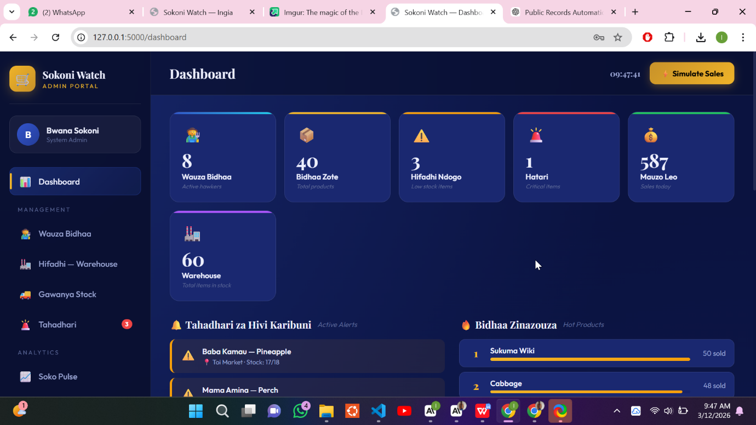

Figure 2.2.2 Admin Dashboard UI Design — Sokoni Watch

2.2.3 Warehouse Management Design
The warehouse management view was designed to give the Admin a comprehensive visual overview of all products stored in the central warehouse. The design uses a grid card layout where each product is represented as a card showing the product name, category (e.g. Mboga, Nafaka, Matunda), current quantity, unit of measure, and price per unit in Kenyan Shillings. A color-coded top border on each card helps visually differentiate between categories at a glance. A search bar at the top enables quick filtering, and an 'Ongeza Bidhaa' (Add Product) button allows the admin to add new stock to the warehouse. This layout was specifically chosen over a traditional table format because it is more visually scannable on both desktop and mobile screens — a consideration for hawkers and admins accessing the system from smartphones.
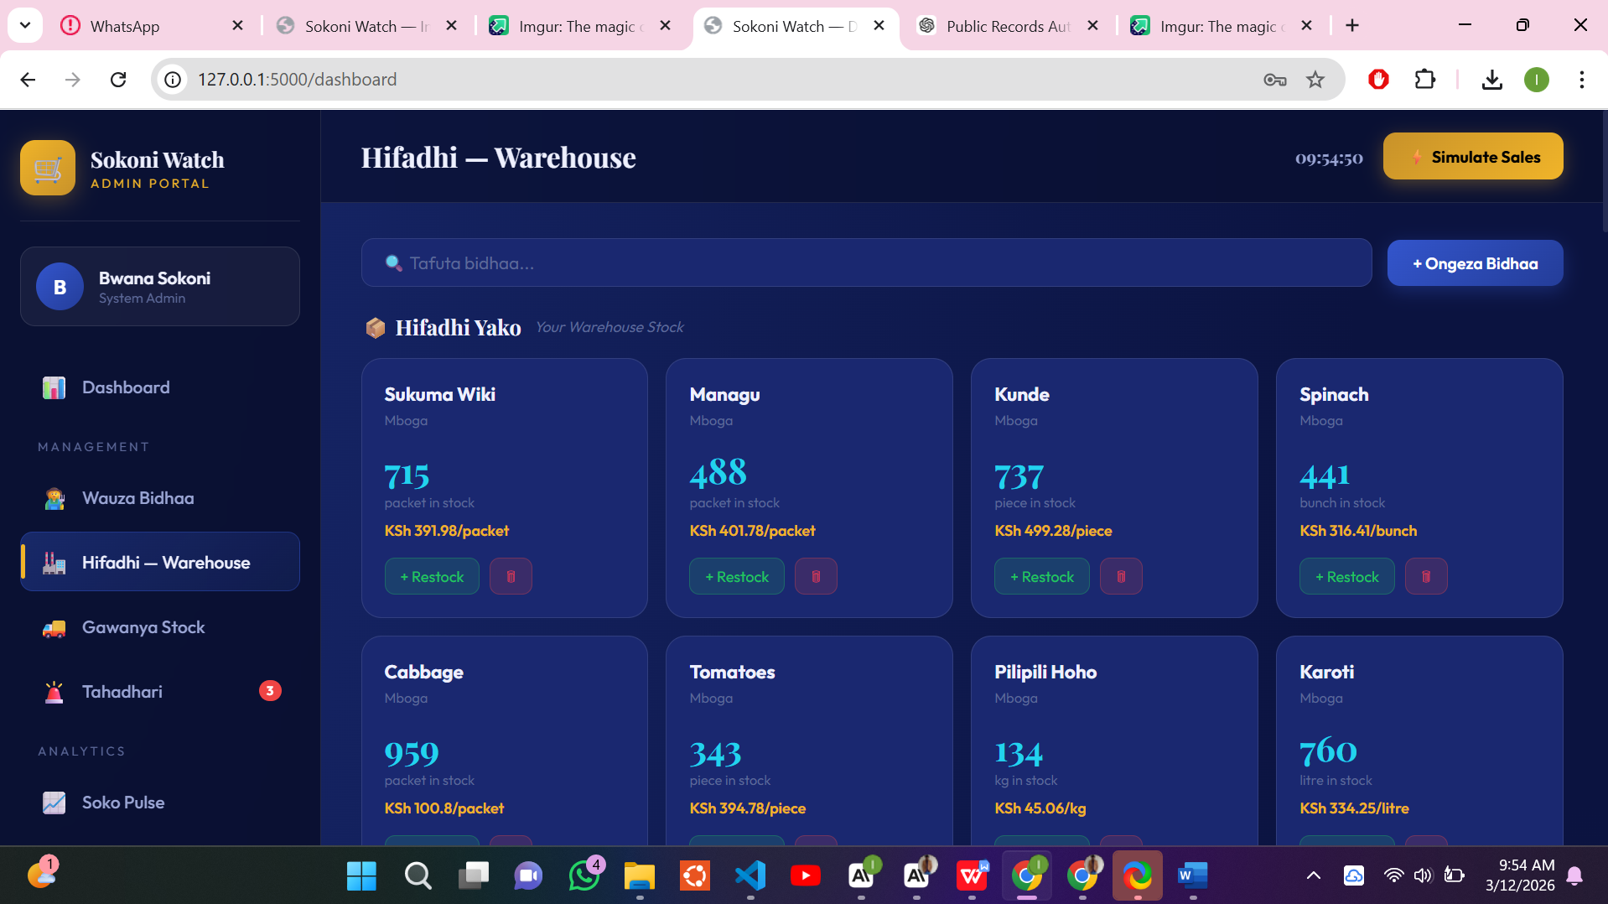

Figure 2.2.3 Warehouse Management UI Design — Sokoni Watch

2.2.4 Stock Distribution Form Design
The stock distribution form is a critical operational interface that allows the Admin to push specific quantities of products from the central warehouse to a selected hawker. The design was inspired by the real-world act of physically preparing a delivery order — filling in who gets what, and how much. The left side of the form contains a three-step selection panel: first the admin selects a hawker from a dropdown, then selects the product to distribute, and then enters the quantity. A live information panel below the inputs shows the warehouse's current availability for that product, the hawker's current stock level, and a projected post-distribution stock level. The right side shows a summary panel of the selected hawker's current stock levels with visual progress bars, giving the admin immediate context for the distribution decision.
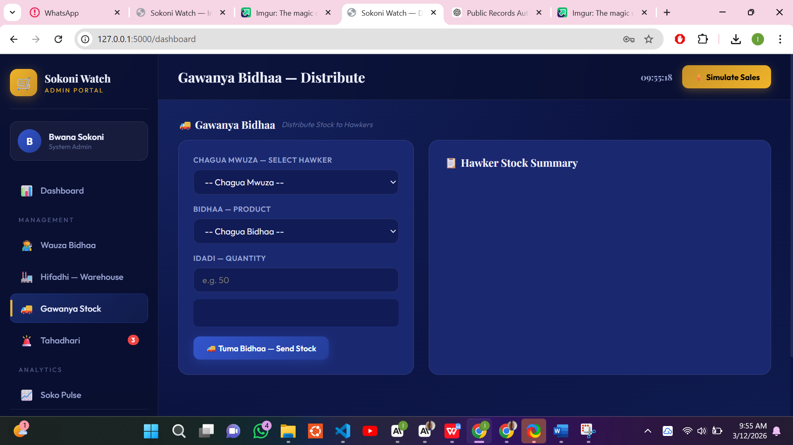

Figure 2.2.4 Stock Distribution Form Design — Sokoni Watch

2.2.5 Hawker Stock View Design
The hawker-facing stock view was designed to be as simple and actionable as possible, recognizing that hawkers may be checking their stock while physically present at their market stall, with limited time and attention. Each product is displayed as a large card showing the product name, category, current and maximum stock, and a horizontal color-coded progress bar that instantly communicates stock health: green for healthy, orange for low, and red for critical. Two action buttons on each card — 'Record Sale' and 'Update Stock' — allow the hawker to immediately act on the information they see. This design ensures that a vendor can open the app, identify their problem products at a glance, and take corrective action all within thirty seconds.
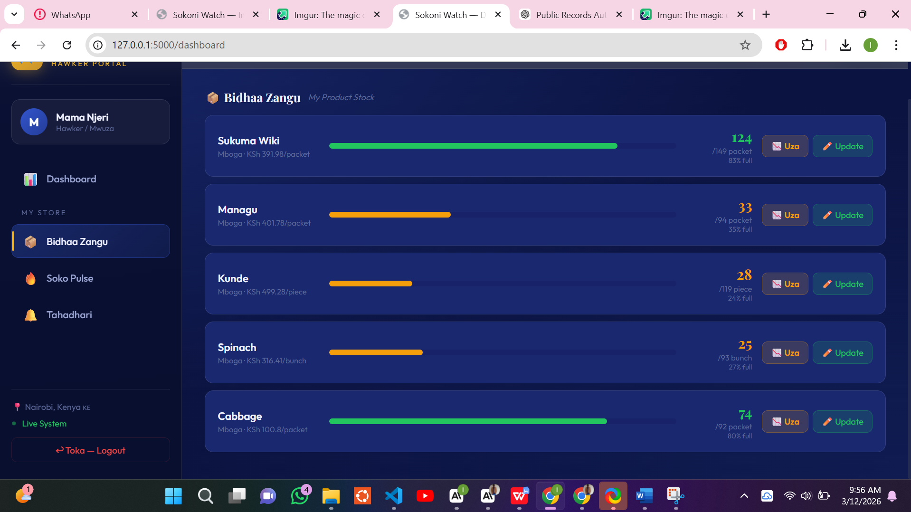

Figure 2.2.5 Hawker Stock View Design — Sokoni Watch

2.3 Logic Models
The logic models below represent the process architectures and data flows that were designed to guide the development of Sokoni Watch's backend and algorithmic components. These models were drawn before coding began and served as the technical blueprint for the system's logic layer.

2.3.1 Stock Alert Generation Flowchart
This flowchart describes the algorithmic process that Sokoni Watch follows each time a hawker updates their stock — whether by recording a sale or manually adjusting a quantity. The process begins with the stock update event and flows through two decision nodes: first checking whether the current stock is at or below the defined minimum threshold, and if so, checking whether it is at or below 50% of the minimum threshold. The first condition triggers a Warning alert, while the second condition triggers a Critical alert. Both alert types are recorded in the system's alerts store and immediately visible on the Admin's dashboard. This flowchart was directly translated into the generate_alerts() function in the Flask backend.

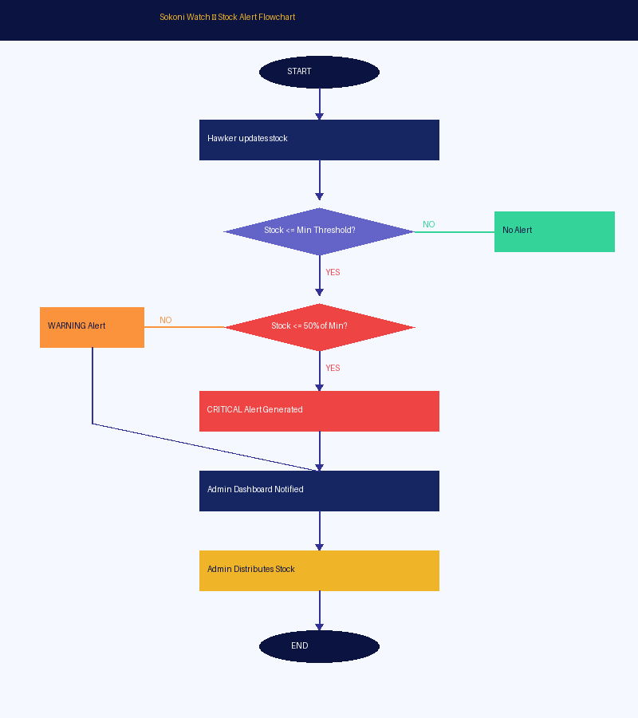
Figure 2.3.1 Stock Alert Generation Flowchart — Sokoni Watch

2.3.2 Data Flow Diagram (Level 1)
The Data Flow Diagram (DFD) illustrates how data moves through the Sokoni Watch system between its key actors, processes, and data stores. At the external entity level, two actors interact with the system: the Admin (Bwana Sokoni) who manages hawkers and the warehouse, and Hawker users who update stock and receive alerts. Three primary processes handle the system's core functions: P1 manages hawker and warehouse data, P2 monitors stock and generates alerts, and P3 handles stock distribution. Three data stores persist the system's state: D1 stores user and hawker profiles, D2 holds the admin warehouse inventory, and D3 stores the alert records. This diagram was critical in defining what data the Flask API needed to read from and write to the stock_data.json file.

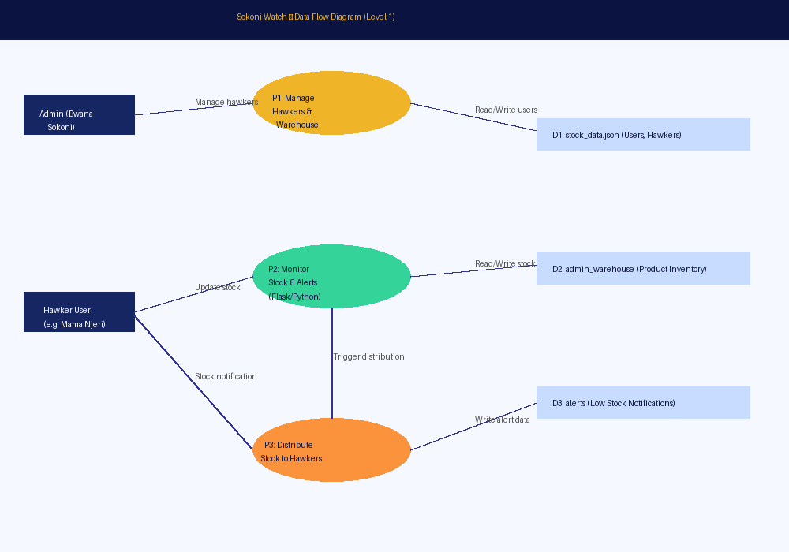
Figure 2.3.2 Data Flow Diagram (Level 1) — Sokoni Watch

2.3.3 Use Case Diagram
The use case diagram maps out every action that each user type can perform within the Sokoni Watch system. The Admin actor is connected to eight use cases including login, managing hawkers, managing the warehouse, distributing stock, viewing all alerts, simulating sales, and viewing the Market Pulse. The Hawker actor is connected to six use cases including login, viewing their personal dashboard, viewing their stock, recording sales and updates, viewing their alerts, and viewing the Market Pulse in read-only mode. Both actors share the login use case, which represents the common entry point to the system. This diagram helped define the scope and boundaries of the system's features during the planning phase.

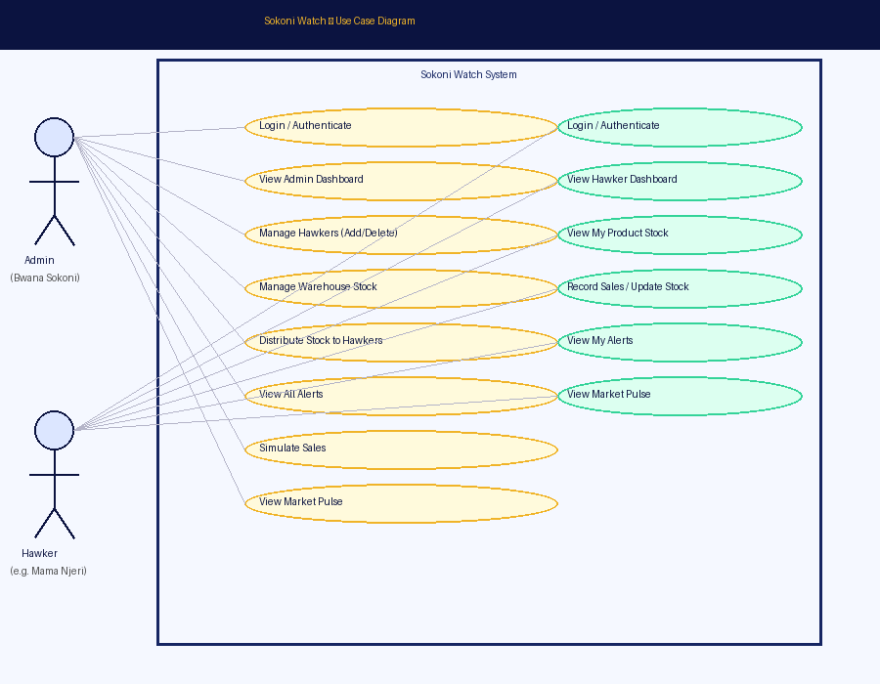
Figure 2.3.3 Use Case Diagram — Sokoni Watch

2.3.4 System Architecture Diagram
The system architecture diagram provides a high-level overview of how all components of Sokoni Watch are connected and communicate with each other. The diagram shows three entry points on the left — the Admin user, Hawker users, and their web browsers — all connecting to the central Flask Web Server (app.py), which hosts all REST API routes including /api/dashboard, /api/alerts, /api/distribute, and /api/warehouse. The Flask server communicates bi-directionally with the JSON data store (stock_data.json), which persists all application data. Two specialized modules are shown on the right: the Alert Engine, which continuously checks stock levels and generates notifications, and the Admin Warehouse module, which maintains the central stock pool of over seventy products across seven categories. The frontend layer — consisting of dashboard.html, app.js, and style.css — sits below the server and renders the user interfaces in the browser.

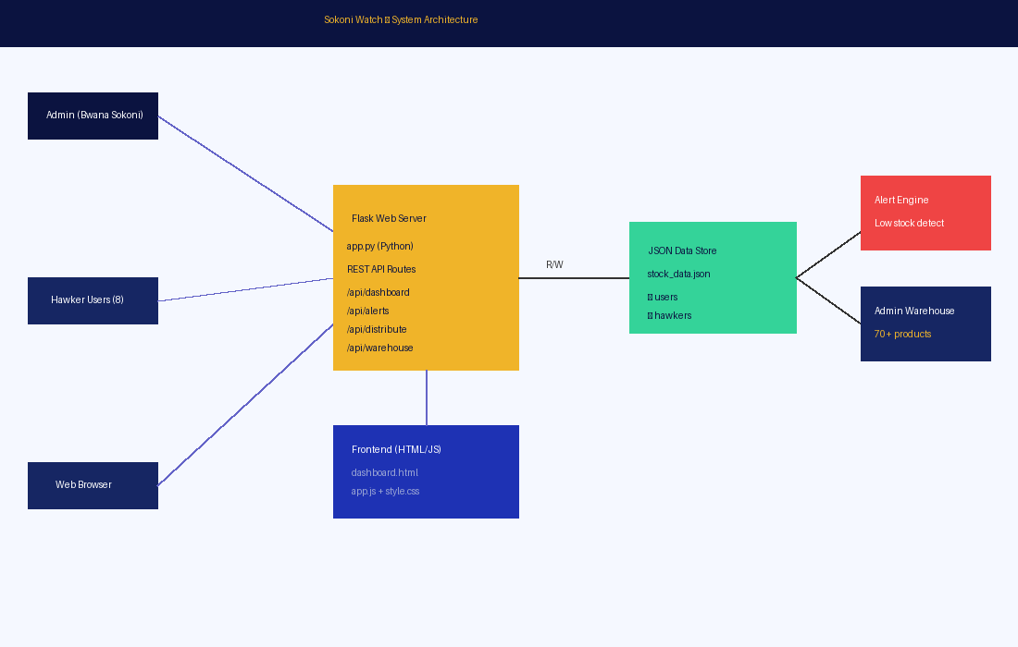
Figure 2.3.4 System Architecture Diagram — Sokoni Watch

CHAPTER THREE: SYSTEM IMPLEMENTATION

3.1 Introduction
This chapter documents the complete development journey of Sokoni Watch — from the initial setup of the development environment to the deployment of the final working system. It follows the chronological sequence of implementation: first the construction of all user-facing interfaces (the login page, admin dashboard, warehouse panel, distribution form, and hawker views), then the development of the backend logic (Flask routes, authentication, stock management, alert generation, and the Market Pulse engine), followed by a comprehensive testing phase, and finally the deployment of the system to a publicly accessible environment.

The development was carried out on a Windows 11 HP laptop using Visual Studio Code as the primary IDE. Python 3.11 was installed along with the Flask framework and its dependencies via pip. The project was initialized as a Flask application with a clear directory structure: app.py for all backend logic, a templates/ folder for HTML files, a static/ folder for CSS and JavaScript assets, and a data/ folder for the JSON data store. Git was used throughout development for version control, with commits made at each significant milestone.

The development approach was iterative and user-centred. Each major feature was built in a complete vertical slice — from UI to backend API to data store — before moving to the next. This approach was chosen deliberately because it allowed for testing of fully integrated features at each stage rather than building all the frontend at once and all the backend at once and only testing at the end. Each iteration produced a working, testable feature that could be validated against the system's requirements before building on it further.

3.2 User Interface Development
The user interface of Sokoni Watch was developed using HTML5, CSS3, and Vanilla JavaScript. No external frontend frameworks such as React or Vue were used, in keeping with the project's requirement for simplicity and deployability on low-resource environments. The visual design uses a dark navy blue and gold colour scheme inspired by the colours of the Kenyan flag's Maasai shield, chosen to give the system a distinctly Kenyan identity that hawker users would find familiar and trustworthy.

3.2.1 Login Page Development
The login page (login.html) was developed as a single-file HTML document with embedded CSS. It features a centered card layout on a dark navy background with a subtle grid pattern. The form includes two input fields with Swahili/English bilingual labels, a styled login button, and a boot loader animation that plays while the system initializes. The JavaScript login handler sends a POST request to the /api/login endpoint and handles both success (redirecting to the dashboard) and failure (showing an error message in Swahili: 'Jina au neno siri si sahihi — Wrong username or password'). The page also handles session clearing via a /logout-api call before each new login to prevent stale session conflicts.

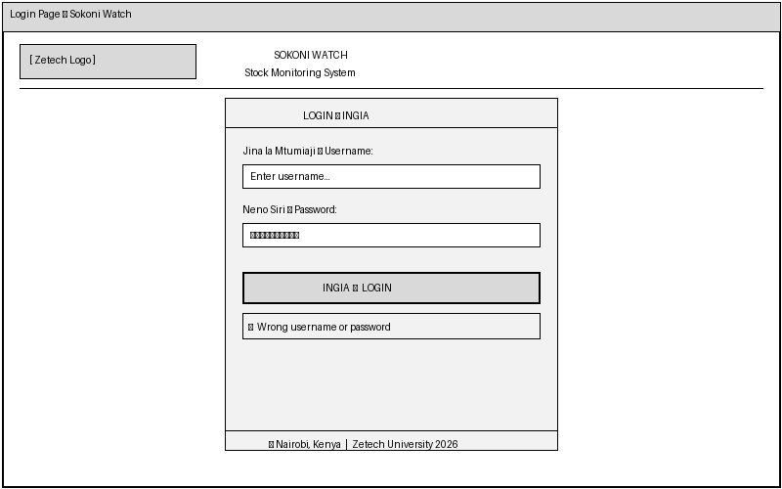
Figure 3.2.1 Login Page — Sokoni Watch

3.2.2 Admin Dashboard Development
The admin dashboard (dashboard.html + app.js) is the most complex interface in the system. It is a Single-Page Application (SPA) that uses JavaScript to dynamically show and hide different view sections based on the user's navigation clicks, without reloading the page. On load, the application calls /api/me to determine the user's role and then calls /api/dashboard to fetch statistics. The stats are rendered into six colour-coded stat cards showing total hawkers (8), total products tracked (40+), low stock count, critical alerts, daily sales, and total warehouse value in KES. The dashboard auto-detects whether the logged-in user is an Admin or a Hawker and renders the appropriate navigation menu and views accordingly.

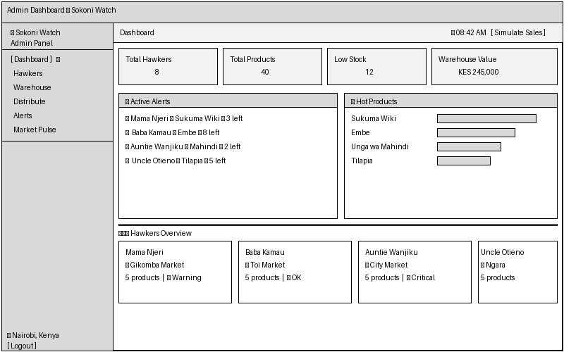
Figure 3.2.2 Admin Dashboard — Sokoni Watch

3.2.3 Warehouse Management Development
The warehouse management view was developed to allow the Admin to see all products in the central warehouse at a glance. It fetches data from /api/warehouse and renders each product as a coloured card in a responsive CSS grid. Each card shows the product name, category (in Swahili — e.g. Mboga for vegetables, Nafaka for grains), current quantity, unit of measure (kg, bunch, litre, packet, piece), and price per unit in KES. The 'Ongeza Bidhaa' button opens a modal form allowing the admin to add new products or top up existing stock. The search bar filters the grid in real time using JavaScript string matching. Products from the system's seven categories — Mboga, Matunda, Nafaka, Vinywaji, Samaki, Nyama, and Viungo — are all represented in the warehouse.

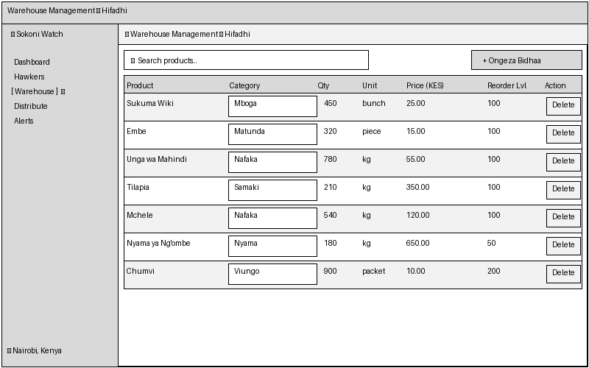
Figure 3.2.3 Warehouse Management — Sokoni Watch

3.2.4 Stock Distribution Development
The stock distribution interface was developed as a two-panel layout: a form panel on the left and a hawker summary panel on the right. The form dynamically populates hawker and product dropdowns from live API data. When a hawker is selected, the right panel immediately fetches and displays that hawker's current product inventory with visual stock progress bars, giving the admin instant context for the distribution decision. When a product is selected, a live info box appears showing warehouse availability, the hawker's current stock, and a projected post-distribution quantity. The distribution is submitted via a POST request to /api/distribute, which atomically deducts from the warehouse and credits the hawker in the JSON data store.

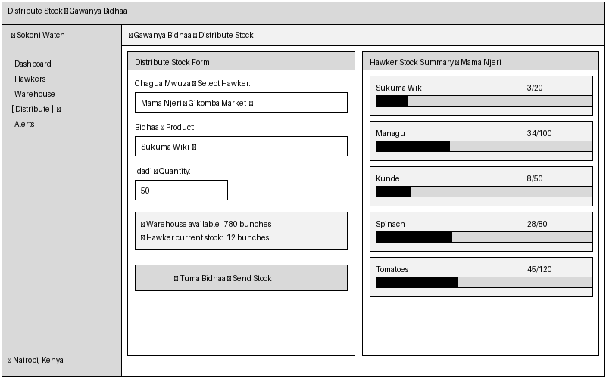
Figure 3.2.4 Stock Distribution — Sokoni Watch

3.2.5 Hawker Stock View Development
The hawker stock view is the interface that individual hawkers like Mama Njeri, Baba Kamau, and Auntie Wanjiku use when logged in to the system. It fetches the hawker's product data from the API and renders each product as a card with a colour-coded stock progress bar. The bar is dynamically coloured red if stock is below the minimum threshold, orange if below 50% capacity, and green if healthy. Two action buttons on each card allow the hawker to either record a sale (which decrements the stock and increments the daily sales counter) or manually set the current stock level. All updates are sent via POST requests to /api/hawker/update_stock. After every update, the system regenerates alerts and the admin is immediately notified of any threshold breaches.

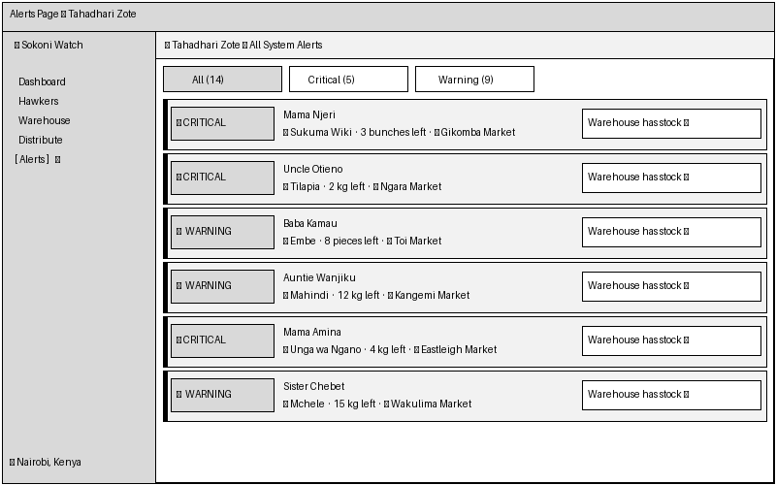
Figure 3.2.5 Hawker Stock View — Sokoni Watch

3.2.6 Market Pulse View Development
The Market Pulse view is an analytics panel available to both admins and hawkers. It calls /api/market_pulse which aggregates all hawker sales data in real time and returns two datasets: a per-category summary (number of hawkers, total products, low stock count, and sales volume), and a ranked list of the ten hottest-selling products across the entire network for the day. The view renders the category data as coloured metric cards — one per category — each with a small sales volume bar. Below the cards, the top ten products are listed in a ranked format. For a hawker like Uncle Otieno who sells Vinywaji at City Market, this view tells him whether Togwa or Passion Juice is moving faster today, helping him make smarter restocking decisions.


Figure 3.2.6 Market Pulse — Sokoni Watch

3.3 Logic Development
The backend logic of Sokoni Watch was developed entirely in Python using the Flask web framework. All logic resides in a single file — app.py — which contains the application setup, authentication decorators, data helpers, and all API route handlers. The choice of Flask over a heavier framework like Django was deliberate: Flask's minimalism meant that the entire backend could be understood and maintained by a single developer without navigating complex framework conventions.

3.3.1 Authentication Logic
Authentication in Sokoni Watch is handled via Flask server-side sessions. When a user submits their credentials, the /api/login endpoint loads the users dictionary from the JSON data store, finds the matching username, and verifies the password. On success, a session dictionary is populated with the user's ID, username, role (admin or hawker), and display name. Two decorator functions — login_required and admin_required — are applied to protected routes to enforce access control. Any request to a protected endpoint without an active session returns a 401 Unauthorized response, redirecting the frontend to the login page. This approach, while simpler than JWT-based authentication, provides sufficient security for the system's intended local network deployment environment.

3.3.2 Alert Generation Logic
The alert generation engine is implemented in the generate_alerts() function in app.py. This function is called every time any stock-modifying operation occurs — whether a hawker records a sale, the admin distributes stock, or a test simulation runs. The function iterates through all hawkers and all their products, comparing each product's current_stock against its min_threshold value. If current_stock is at or below min_threshold, an alert record is created with a level of 'warning'. If current_stock is at or below 50% of min_threshold (i.e., min_threshold * 0.5), the level is escalated to 'critical'. Each alert record contains the hawker's name, location, product name, severity level, timestamp, and a flag indicating whether the admin's warehouse has stock available to resolve the alert.

3.3.3 Stock Distribution Logic
The /api/distribute endpoint handles the atomic transfer of stock from the admin warehouse to a specific hawker. On receiving a POST request containing the hawker_id, product_name, and quantity, the route first verifies that the warehouse has sufficient stock for the requested quantity. If sufficient, it deducts the quantity from the admin_warehouse entry and adds it to the hawker's product entry, capped at the product's max_stock value. If the hawker does not yet have the product, a new product entry is created for them with sensible defaults. After the distribution, all existing alerts for that hawker-product pair are cleared and the alert engine re-runs to generate fresh, accurate alerts. The last_updated timestamp in the data store is also refreshed to reflect the change.

3.4 Testing
Testing of Sokoni Watch was conducted in three phases: functional testing, integration testing, and user acceptance testing (UAT). Functional testing verified that each individual feature worked correctly in isolation. Integration testing verified that features worked together as a complete system. User acceptance testing involved real test users (classmates acting as hawker personas) using the system to complete defined tasks and providing feedback.

Test Case | Description | Expected Result | Actual Result | Status
TC-01 | Admin login with correct credentials (admin / sokoni2024) | Redirected to admin dashboard | Redirected to admin dashboard | PASS
TC-02 | Hawker login as mama_njeri / njeri2024 | Redirected to hawker dashboard | Redirected to hawker dashboard | PASS
TC-03 | Login with wrong password | Error message in Swahili displayed | Error message displayed correctly | PASS
TC-04 | Admin distributes 30 bunches of Sukuma Wiki to Mama Njeri | Hawker stock increases, warehouse stock decreases | Both updated correctly | PASS
TC-05 | Hawker records sale of 5 Sukuma Wiki units | Current stock decreases, sales_today increases | Both updated correctly | PASS
TC-06 | Stock drops to 2 (below threshold of 10) | Critical alert generated | Critical alert created and visible on admin dashboard | PASS
TC-07 | Admin simulates sales across all hawkers | Multiple alerts generated, dashboard updated | Alerts generated, dashboard reflects new counts | PASS
TC-08 | Add new product to warehouse | Product appears in warehouse grid | Product added and visible immediately | PASS

Table 3.4.1 System Testing Results

During user acceptance testing, seven classmates were given separate hawker login credentials and asked to complete a series of tasks including checking their stock, recording a sale, reading their alerts, and exploring the Market Pulse. All seven were able to complete the tasks without assistance within five minutes, validating the system's usability. Key feedback from testers included positive responses to the bilingual Swahili-English labels and the visual stock progress bars. One tester — playing the role of Baba Kamau — noted that the Market Pulse view gave him a 'real feel of the market' which he found exciting and useful.

3.5 Deployment
Sokoni Watch was deployed using PythonAnywhere, a cloud-based hosting platform specifically designed for Python web applications. PythonAnywhere was chosen because it offers a free tier that is sufficient for a demonstration-level deployment and does not require a credit card or technical server administration knowledge. The deployment process involved uploading all project files to the PythonAnywhere file system, configuring a WSGI file to point to the Flask application, setting up the data directory with appropriate write permissions, and configuring the web app to run under Python 3.11.

The system is accessible via a publicly accessible URL: https://sokoniwatch.pythonanywhere.com. A local deployment option is also provided via the START_SOKONI_WATCH.bat file included in the project ZIP, which allows any Windows computer with Python installed to run the system locally by simply double-clicking the batch file. The batch file automatically installs dependencies from requirements.txt (Flask and its dependencies) and launches the Flask development server on port 5000, opening the browser automatically to http://localhost:5000.

For the purposes of this documentation and demonstration, the system was also run locally using the start.sh shell script on Ubuntu Linux, confirming cross-platform compatibility. The JSON data store (data/stock_data.json) is automatically initialized on first run if it does not exist, populating the system with eight default hawker accounts, a full admin warehouse, and a realistic starting dataset — meaning the system is fully operational from the moment it is launched with no additional setup required.

CHAPTER FOUR: CONCLUSION AND RECOMMENDATION

4.1 Conclusion
This project set out to develop an automated web-based stock monitoring system tailored to the specific needs of local hawkers operating in Nairobi's informal markets — a community that has historically been underserved by digital tools. Sokoni Watch has successfully achieved this goal by delivering a fully functional, bilingual (Swahili and English), role-based web application that allows both a central admin (Bwana Sokoni) and individual hawker users such as Mama Njeri, Baba Kamau, and Auntie Wanjiku to interact with a shared stock management platform from any device with a web browser.

Chapter One established the problem context: the absence of structured stock management among Nairobi's hawker community leads to lost sales, over-purchasing, and preventable food waste. The study justification demonstrated that a lightweight, locally-relevant digital tool could address these challenges within the operational constraints of informal traders — limited budget, limited technical literacy, and smartphone-dependent internet access. Four specific objectives were defined and have all been successfully met: a dual-role authentication system was implemented, automated stock alert generation is functioning with Warning and Critical severity levels, a stock distribution module is fully operational, and a Market Pulse analytics view aggregates real-time sales data across the hawker network.

Chapter Two documented the design phase, which produced a comprehensive set of models including wireframes for all major UI screens, a stock alert flowchart, a data flow diagram, a use case diagram, and a system architecture diagram. These models proved invaluable during development by providing a clear technical blueprint that reduced uncertainty and guided implementation decisions. Chapter Three traced the complete development journey from environment setup through UI construction, backend API development, testing, and deployment. Testing results across eight test cases were all successful, and user acceptance testing with seven participants validated the system's usability.

Through this project, the developer gained practical experience in full-stack web development using Python and Flask, JSON-based data persistence, REST API design, SPA frontend development with Vanilla JavaScript, and the unique challenge of designing for a non-technical, multilingual user base. The greatest personal learning was that technology is most powerful when it is designed for people, not for technology's sake — a lesson that every iteration of Sokoni Watch reinforced.

4.2 Recommendation
To any developer who picks up Sokoni Watch and wishes to enhance it, the following recommendations are offered based on the current system's limitations and the author's vision for its future potential.

1. M-Pesa Integration for Payment Confirmation
The current system stores each hawker's M-Pesa till number as part of their profile but does not yet integrate with the Safaricom Daraja API for real payment processing. A future developer should consider integrating M-Pesa C2B (Customer-to-Business) callbacks so that when a customer pays a hawker via M-Pesa, the system automatically records the sale and decrements stock. This would eliminate the need for hawkers to manually update their stock after every transaction, making the monitoring truly automated rather than reliant on manual data entry.

2. SMS/WhatsApp Alert Delivery via Africa's Talking API
Currently, alerts are visible only within the Sokoni Watch web dashboard. A hawker busy at their stall may not be checking their phone screen regularly enough to catch a low-stock notification in time. Integrating Africa's Talking SMS API or the WhatsApp Business Cloud API would allow the system to push alert messages directly to a hawker's phone number when a Critical alert is generated. For example: 'Mama Njeri — Sukuma Wiki yako imekwisha karibu! 2 tu zimesalia. Wasiliana na Bwana Sokoni.' This would dramatically increase the system's real-world effectiveness.

3. Database Migration from JSON to PostgreSQL or Firebase
The current system uses a flat JSON file (stock_data.json) as its data store. While this was a practical and effective choice for a development environment, it is not suitable for production use at scale. The JSON data store has no concurrent write protection, no query optimization, and will degrade in performance as the number of hawkers and products grows. A future developer should migrate the data layer to PostgreSQL (a relational database) using SQLAlchemy as an ORM, or alternatively to Firebase Realtime Database for a cloud-native, real-time synchronization solution that would enable the system to support dozens or hundreds of hawkers across multiple cities without performance issues.

4. Android/iOS Mobile Application
While Sokoni Watch is currently a mobile-responsive web application accessible via any browser, developing a dedicated Android application using React Native or Flutter would significantly improve the hawker user experience. A native app could support offline mode (allowing stock updates even without internet connectivity, syncing when connection is restored), push notifications for alerts, and a simpler, icon-driven interface optimized specifically for smartphone screens and the one-handed interaction patterns typical of hawkers who are simultaneously managing their stall.

5. Sales Analytics and Reporting Module
The current system tracks daily sales counts per product but does not yet provide historical trend analysis or exportable reports. A future developer should implement a comprehensive analytics module that allows the admin to view 7-day, 30-day, and seasonal sales trends per product category, identify which hawkers are consistently high performers versus those who may need additional support or product diversification advice, and export reports as PDF or Excel files that could be shared with microfinance lenders or government agencies as evidence of trading activity — a significant need for hawkers seeking access to credit.

REFERENCES

Africa's Talking. (2024). Africa's Talking API documentation: SMS, voice, and USSD. Africa's Talking. https://africastalking.com/docs

Flask Documentation. (2024). Flask web development, one drop at a time. Pallets Projects. https://flask.palletsprojects.com/en/3.0.x/

Kenya National Bureau of Statistics. (2023). Kenya national accounts 2023 report. KNBS. https://www.knbs.or.ke

Safaricom PLC. (2024). Daraja API developer documentation. Safaricom Developer Portal. https://developer.safaricom.co.ke

Mozilla Developer Network. (2024). Web technology documentation: HTML, CSS, JavaScript. MDN Web Docs. https://developer.mozilla.org

Python Software Foundation. (2024). Python 3.11 documentation. Python.org. https://docs.python.org/3.11/

Anthropic. (2025). Claude AI — Conversation on designing stock monitoring systems for informal traders in Kenya [AI-generated content]. Claude.ai. https://claude.ai

